Year 8 | Knowledge Organiser: Asia
Maps of Asia  1. There are 48 countries in Asia  2. More than 4.4 billion people live on the continent.  3. Largest Country: Russia by landmass, even though roughly 40% of the country belongs to the European continent.  4. Asia Facts - Largest City: Shanghai in China. With more than 24 million inhabitants  6 Longest River: Yangtze River is the longest on the Asian continent. It is in China. (6,300metres/3,915miles). The Yangtze is the third longest river in the world after the Amazon and the Nile. | 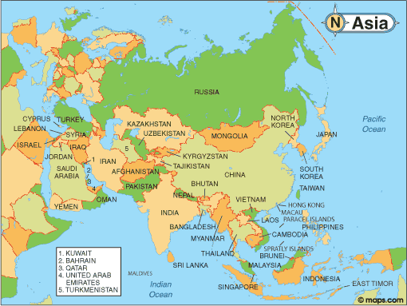
Important Human & Physical Features of Asia | Human features:  - India, China, Japan, Mongolia, Russia, Thailand, Burma, Pakistan, Kazakhstan, Vietnam, Taiwan, Philippines  Physical features:  - Arabian Sea, Bay of Bengal, Pacific Ocean, East China Sea  - Himalayas, Altai mountains, Gobi Desert
Population Distribution | 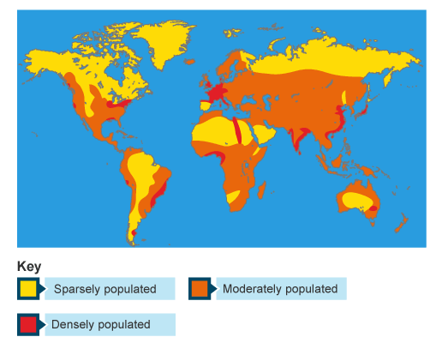 | KEYWORDS | DEFINITIONS
 |  | Population Density  Sparsely Populated  Densely Populated | The number of people living in a km².  There are a few people in one area  There are lots of people in one area
Population Structure  The population structure of a country is how it is made up of people of different ages, and of males and females.  The common method to show the structure is a population pyramid. | 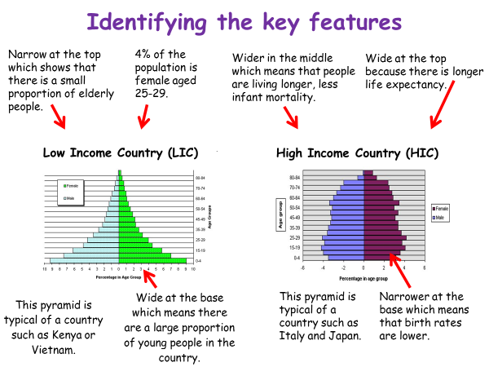 | Impacts of Overpopulation  Food Shortages  Water Shortages  Air Quality  Mass Deforestation | 1 billion will go hungry. 18,000 children will die every day from a lack of food  1 billion lack access to sufficient water for farming and sanitation  This will reduce and become more polluted due to burning fossil fuels  Huge areas of rainforest cut down for food production and for burning wood

