Year 7 | Knowledge Organiser: Weather & Climate | Key words
The Water Cycle  Shows the circulation of the earth’s water |  | Evaporation  Condensation  Precipitation  Surface run off  Groundwater flow  Transpiration | When the sun heats up water from the sea and it goes into the air  When water vapour cools and turns into clouds  Rain, snow, sleet, or hail that falls to or condenses on the ground  When water runs off the surface of the ground  When water flows through the rocks and soil under the ground  When the sun heats up water from the leaves of the trees
Weather Symbols |  | Weather  Weather Symbols  Weather Forecast | Weather is what it is like at a particular place at a particular time. You often look at the weather on a daily basis (short time period)  Weather symbols are used on weather maps as shorthand for the conditions in the atmosphere  Weather forecasting is the application of science and technology to predict the conditions of the atmosphere for a given location and time
 |  | Climate | Climate is what the weather is like over a long time period. For example over 30 years. It uses records of the weather to say what the climate is like.
Measuring the weather | What do we measure?  - Temperature  - Precipitation, e.g. rainfall  - Wind speed and direction  - Cloud cover and visibility  - Air pressure  - Humidity (amount of water vapour in the air) | Temperature | Temperature is a degree of hotness or coldness the can be measured using a thermometer
 |  | Wind Direction & Wind Speed  Barometer | Wind direction is reported by the direction from which it originates. Wind speed is measured in km/h. Measured using an Anemometer  An instrument measuring atmospheric pressure, used especially in forecasting the weather
 |  | Rain Gauge  Thermometer  Oktas Scale | A device for collecting and measuring the amount of rain which falls  An instrument for measuring and indicating temperature measured in degrees Celsius  An okta is a unit of measurement used to describe the amount of cloud cover at any given location such as a weather station. Sky conditions are estimated in terms of how many eighths of the sky are covered in cloud, ranging from 0 oktas (completely clear sky) through to 8 oktas (completely overcast)
Climate graph | 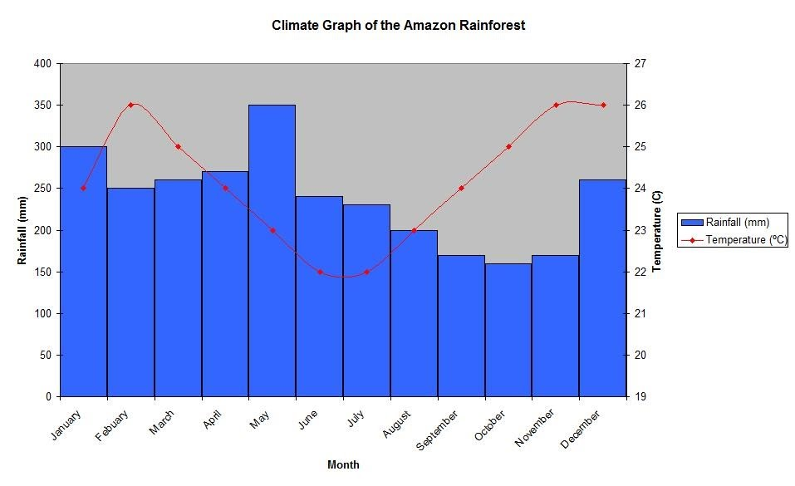 | Climate graph | Climate graphs show average rainfall and temperatures typically experienced in a particular location. The temperature is shown on a line graph, and rainfall on a bar graph.
Types of rainfall |  | Relief Rainfall | Prevailing winds bring warm, moist air to the western British Isles. Air is forced to rise over high areas. Air cools and condenses. Clouds form and it rains.
 |  | Frontal Rainfall | When cold air and warm air meet the warmer air rises over the top of the colder, heavier air. Condensation occurs and clouds form resulting in rain.
 |  | Convectional Rainfall | When the land warms up, it heats the air above it. This causes the air to expand and rise. As the air rises it cools and condenses. If this process continues then rain will fall.

