Year 7 | Knowledge Organiser: South America
Maps of South America  1. There are 12 countries in South America  2. Largest Country: Brazil. The country is covering more than half the continent's landmass.  3. Largest City: Sao Paolo in Brazil. With more than 20 million inhabitants.  4. Smallest Country: Suriname. The country is one of the 10 most sparsely populated countries in the world.  5. Longest River: Amazon River (6,437metres/4,000miles). | 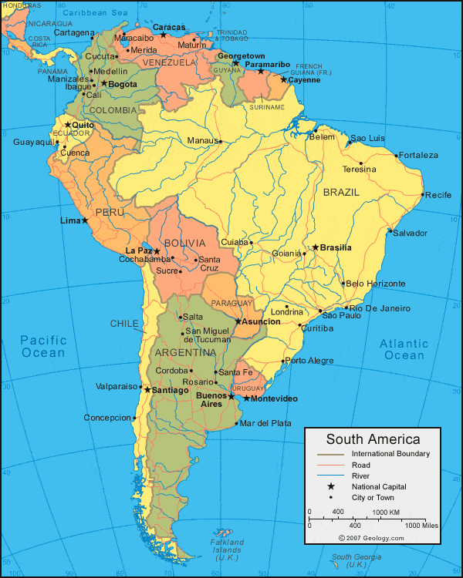  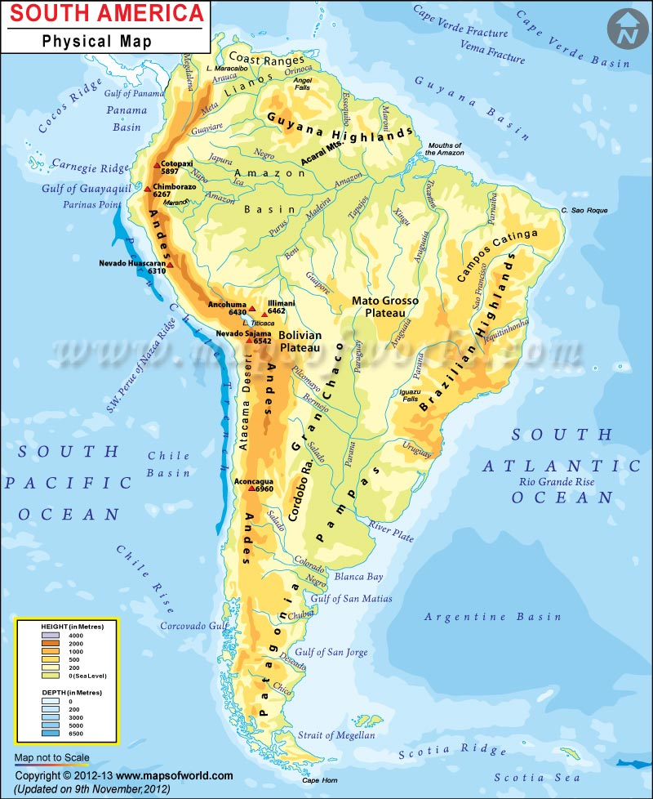
Important Human & Physical Features of South America | Oceans: South Atlantic Ocean and Pacific Ocean.  Countries: Argentina, Bolivia, Brazil, Chile, Colombia, Ecuador, Guyana, Paraguay, Peru, Suriname, Uruguay and Venezuela.  Physical features: Andes Mountains, Amazon River, Atacama Desert, Amazon Rainforest, Brazilian Highlands, Guyana Highlands.  Capital cities: Buenos Aires, Sucre, Brasilia, Santiago, Bogota, Quito, Georgetown, Asuncion, Lima, Paramaribo, Montevideo, Caracas
Development Indicators  In Geography we classify countries according to how developed they are. This means how ‘rich’ they are in comparison to other countries.  We measure development through indicators. These show if a country is a LIC (Low Income Country), a NEE (Newly Emerging Economy) or a HIC (High Income Country). | 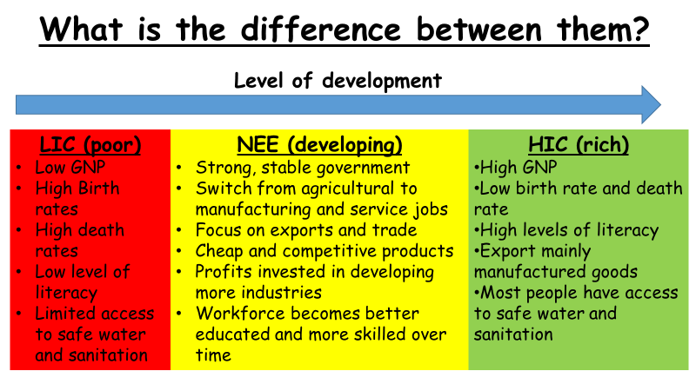 | KEYWORDS | DEFINITIONS
 |  | Literacy Rate  Infant Mortality  Life Expectancy  Birth Rate  Death Rate  Gross National Product  Population Density | % of adults who can read and write.  Number of babies born per 1,000 who die before their 1st birthday.  The average age a person lives.  The number of people born per 1,000 of the population.  The number of people who die per 1,000 of the population.  A measure of the average national income of a person in a country.  The number of people living in a km².
Where do we find Rainforests?  A tropical rainforest is a hot, humid ecosystem found near the equator.  They contain the most diverse range and highest volume of plant and animal life found anywhere on earth. | 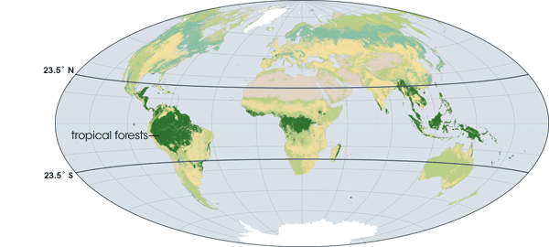 | Layers of the Rainforest  Emergent  Tallest tress – as high as 200 feet!  Canopy  Primary layer. Many animals live here as food is abundant.  Under Canopy  Little sunshine. Plants have large leaves to reach the sun.  Shrub Level  Very dark – almost no plants. | 